CSO-1030A (7-15) | ARIZONA DEPARTMENT OF CHILD SAFETY  CHILDS Payment Unit – Site Code C010-01  P.O. Box 6030  Phoenix, AZ 85005-6030  Telephone: 602-255-3300
DCS ELECTRONIC FUNDS TRANSFER AUTHORIZATION AGREEMENT
Please read and understand all terms and conditions on the back of this agreement. Complete this DCS Electronic Funds Transfer Authorization Agreement with your correct information, sign and date, attach all required documents, and submit to the address above. Incomplete forms will be returned.
*Required fields
*PROVIDER/FACILITY NAME

*PROVIDER ID = FEIN or SSN |  |  |  |  |  |  |  |  |  |  |  |  |  |  |  | PROVIDER SUFFIX |  |  |  |  |  |  |  |  |  |  |  |  | FACILITY ID
*ACTION  New Change Cancel |  |  |  |  |  |  |  |  |  |  |  |  |  |  |  |  |  | *EFFECTIVE DATE |  |  |  |  |  |  |  | *EMAIL ADDRESS (see #2 below) (Required to receive Warrant Advice)
*MAILING ADDRESS (No., Street, City, State, ZIP) |  |  |  |  |  |  |  |  |  |  |  |  |  |  |  |  |  |  |  |  |  |  |  |  |  |  |  |  |  |  |  |  |  | *DAYTIME CONTACT PHONE NUMBER
*NAME OF FINANCIAL INSTITUTION

*ACCOUNT NUMBER (Include hyphens but omit spaces and special symbols) |  |  |  |  |  |  |  |  |  |  |  |  |  |  |  |  |  |  |  |  |  |  |  |  |  |  |  |  |  |  | *TYPE OF ACCOUNT  Checking Savings
*ROUTING TRANSIT NUMBER |  |  |  |  |  |  |  |  |  |  |  |  |  |  |  |  |  |  |  |  | (All 9 boxes must be filled. The first two numbers  must be 01 through 12 or 21 through 32) |  |  |  |  |  |  |  |  |  |  |  | *OWNERSHIP OF ACCOUNT  Self Joint Other
By signing this authorization agreement, I certify that I have read and understand all terms and conditions on the back of this agreement. I authorize DCS to initiate credit entries to the account indicated above for the purpose of payments to my account. I also authorize DCS to initiate, if necessary, debit entries and adjustments for any credit entries made in error. I will notify the State of Arizona of any known changes or cancellations of my bank account or email address. Your enrollment in the DCS Electronic Funds Transfer Program may be cancelled if your email address is incorrect. When the State of Arizona is notified by my financial institution of changes affecting this account, the State of Arizona is authorized to make applicable changes. This authorization agreement is to remain in effect until a new authorization agreement is received.
*Signature |  |  |  |  |  |  |  |  |  |  |  |  |  |  |  |  |  |  |  |  |  |  |  |  |  |  |  |  |  |  |  | Date
*Signature (see #5 below) |  |  |  |  |  |  |  |  |  |  |  |  |  |  |  |  |  |  |  |  |  |  |  |  |  |  |  |  |  |  |  | Date
HOW TO COMPLETE THIS FORM

1. Read and understand all terms and conditions on the back of this agreement.
2. To update EMAIL ADDRESS ONLY, email DCYFCHILDSeft@azdes.gov with Provider ID number,
old email address and new email address. This form is not required for email address change only.
3. Fill in all boxes above, sign and date the agreement.
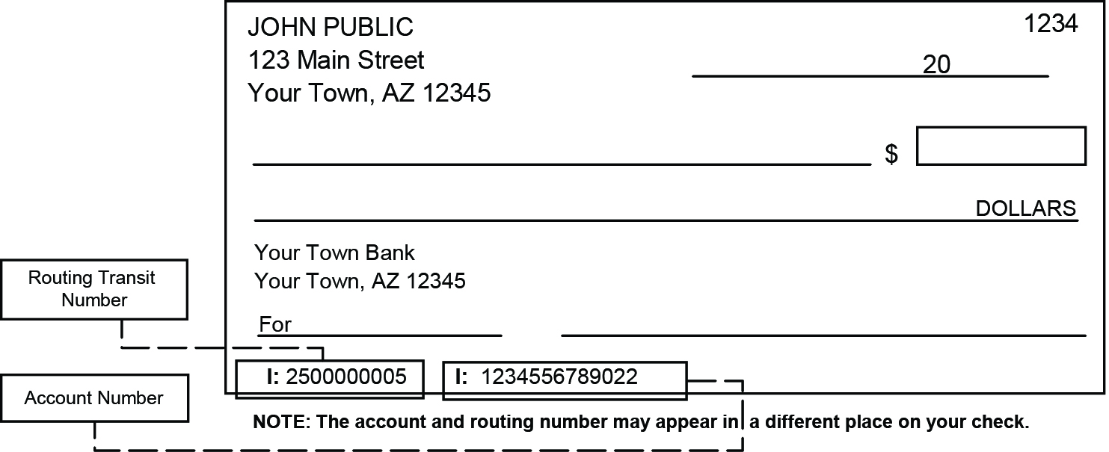
4. For deposit to a checking account, attach a VOID check. For a savings account, attach a signed statement from your financial institution. Deposit slips or checks without current name and address are not accepted.
5. If the account is a joint account, you must also have the joint account holder sign this agreement.
6. Mail this agreement to:
DCS CHILDS Payment Unit - C010-01
P.O. Box 6030
Phoenix, AZ 85005-6030
DO NOT fax or email! Only original signatures can be processed.


Call your financial institution to make sure they will accept electronic transfers.
Verify your routing transit number and account number with your financial institution.

TERMS AND CONDITIONS FOR PARTICIPATING IN THE
DCS DIRECT ELECTRONIC FUNDS TRANSFER PROGRAM

You have the option of having your compensation deposited directly into your checking or savings account at your financial institution, rather than receiving compensation via US Mail.
To participate in the DCS Electronic Funds Transfer Program:
- You must have a checking or savings account. Pre-paid credit card accounts are not accepted.
- Your financial institution must be a member of the Automated Clearing House (ACH). It is your responsibility to check with your financial institution prior to completing this enrollment form.
- An active email address is required to participate in the DCS Electronic Funds Transfer Program.
- To begin the enrollment process in the DCS Electronic Funds Transfer Program, complete this DCS Electronic Funds Transfer Authorization Agreement with your correct information, sign and date, attach all required documents, and submit to:
DCS CHILDS Payment Unit – C010-01
P.O. Box 6030
Phoenix, AZ 85005-6030
- For Electronic Funds Transfer into your:
  - Checking – You must attach a VOID check or a statement signed by your financial institution on their letterhead, containing your name, the correct routing number and your current account number. Deposit slips or checks without your name and current address cannot be accepted.
  - Savings – You must attach a statement signed by your financial institution on their letterhead, containing your name, the correct routing number and your current account number. Deposit slips are not accepted.
- If you have a joint account, the VOID check or statement from your financial institution must contain both names, and the DCS Electronic Funds Authorization Agreement must be signed by both parties.
- Once the DCS Electronic Funds Authorization Agreement is submitted and received by DCS, there may be a four-week processing period before your enrollment becomes effective. You will continue receiving compensation via US mail during this period. DCS compensation will be paid in accordance with DCS Policies and Procedures.
- Once your enrollment is activated, the standard turn-around time for compensation into your checking or savings account is 72 hours from the time DCS transmits the entries. You should always verify that the transfer has been made to your account prior to withdrawing any funds.
- If a DCS Electronic Funds Transfer is returned to DCS or cannot be made to your account for any reason, DCS will compensate you via US Mail, pending resolution of the transfer issue. This process could take up to two weeks.
- It is your responsibility to complete and submit a new DCS Electronic Funds Transfer Authorization Agreement notifying DCS immediately of any changes/cancellations that may affect your DCS Electronic Funds Transfer.
  - Requesting a CHANGE to your agreement:
i. Complete the agreement indicating “CHANGE”
as the ACTION, and enter your new financial institutions routing number and/or account number.
ii. Once your DCS Electronic Funds Transfer Authorization Agreement is received and processed by DCS, the change becomes effective immediately.
  - To CANCEL your enrollment in the DCS Electronic Funds Transfer Program:
i. Complete the agreement indicating “CANCEL” as the ACTION.
ii. Once your DCS Electronic Funds Transfer Authorization Agreement is received and
processed by DCS the cancellation becomes effective immediately.
- DCS reserves the right to temporarily suspend or cancel your enrollment in this program at any time. This enrollment may also be automatically cancelled by your financial institution. Re-enrollment in the DCS Electronic Funds Transfer Program will be determined on a case-by-case basis, and you will be notified by DCS of any action taken.
- DCS reserves the right to cancel your enrollment in this program if your email address changes and DCS is not notified, or if DCS receives notice that email sent to your email address on record is undeliverable.
If you have any questions regarding this form or the DCS Electronic Funds Transfer Program, please call the DCS Payment Processing Unit at 602-255-3300, Monday through Friday, 8 a.m. to 5 p.m., Mountain Standard Time.

Equal Opportunity Employer/Program • Under Titles VI and VII of the Civil Rights Act of 1964 (Title VI & VII), and the Americans with Disabilities Act of 1990 (ADA), Section 504 of the Rehabilitation Act of 1973, the Age Discrimination Act of 1975, and Title II of the Genetic Information Nondiscrimination Act (GINA) of 2008; the Department prohibits discrimination in admissions, programs, services, activities, or employment based on race, color, religion, sex, national origin, age, disability, genetics and retaliation. The Department must make a reasonable accommodation to allow a person with a disability to take part in a program, service or activity. For example, this means if necessary, the Department must provide sign language interpreters for people who are deaf, a wheelchair accessible location, or enlarged print materials. It also means that the Department will take any other reasonable action that allows you to take part in and understand a program or activity, including making reasonable changes to an activity. If you believe that you will not be able to understand or take part in a program or activity because of your disability, please let us know of your disability needs in advance if at all possible. To request this document in alternative format or for further information about this policy, contact your local office; TTY/TDD Services: 7-1-1. • Free language assistance for Department services is available upon request. • Disponible en español en línea o en la oficina local.

